**New to Frasers - Zara in Singapore**

Zara's strategy is **to offer a higher number of available products than its competitors**. While most clothing retailers manufacture and offer to the public for sale 2,000 to 4,000 different articles of clothing, Zara's production has been markedly higher, at over 10,000 pieces produced per year.

## ****Vision Statement****

Zara vision statement is “**to contribute to the sustainable development of society and that of the environment with which we interact**.” Its main parts include:

1. **Developing society**
2. **Improving the environment**

Through its corporate social responsibility, Zara keeps demonstrating its [responsibility to improvement of the lives](https://www.zara.com/ww/en/sustainability-l1449.html?v1=742016) of people. Moreover, the company also supports a wide range of environmentally-conscious programs to support the stability and preservation of natural resources.

## ****Core Values****

Zara core values include “**beauty, clarity, functionality, and sustainability**.” The company uses these as the guiding principles in its operations.

As a fashion company, Zara acknowledges the importance of fostering progressive cultures to stay alert and updated with market demands.

# **Zara Shops – 8 Clothing Stores in Singapore**

There are a total of 8 Zara shops in Singapore for the Spanish clothing stores chain, including a 15,000 sq. ft. flagship outlet at The Shoppes at Marina Bay Sands (10 Bayfront Avenue).

Established in 1975 in Spain by Amancio Ortega and Rosalía Mera, the company is today one of the most recognized global fashion brands for women’s & men’s clothing and accessories.

They are best known for a fast fashion concept, an extremely quick design process, which adapts rapidly to the changing trends and tastes of the buying customers, with new articles reaching the stores twice a week.

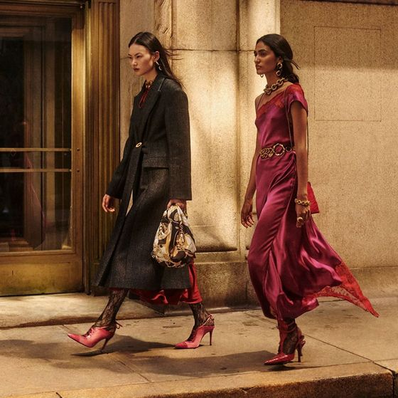

Thanks to this fast turnaround time and short production cycle propelled by a 200-person strong design team, the company brings about 10,000 new products to its shops annually.

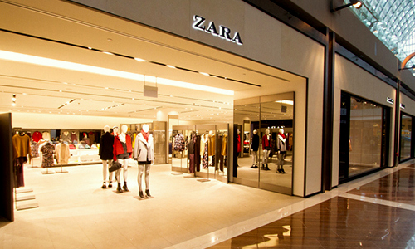

*Marina Bay Sands.*

In other words, whenever you shop at the stores, you are always sure to find something unique and at the sharpest edge of the current fashion trends.

Collections available in Singapore include women’s, men’s, and children’s clothing lines, as well as shoes and accessories.

The company’s [clothing stores](https://shopsinsg.com/clothing-stores) themselves are a pleasure to visit, as they have been built on principles of simplicity, beauty, clarity, functionality, and sustainability, to resemble an intimate boutique and the associated friendly atmosphere.

## Zara Shops – Locations – Clothing Stores in Singapore

**313@Somerset**  
313 Orchard Road, #B1-01 to 05, #01-01 to 05, #02-01 to 06, 313@Somerset  
Singapore 238895  
Opening Hours: Monday-Thursday 10am-10pm, Friday-Saturday 10am-11pm, Sunday 10am-10pm  
Collections: Women, Men, Clothes Collection Programme  
[zara.com/sg/](https://www.zara.com/sg/)

**Great World**  
1 Kim Seng Promenade, #01-158, Great World  
Singapore 237994  
Opening Hours: Monday-Sunday 10am-9:30pm  
Collections: Women, Men, Kids

**ION Orchard**  
2 Orchard Turn, #B2-03 & #B3-05, ION Orchard  
Singapore 238801  
Opening Hours: Monday-Sunday 10am-10pm  
Collections: Women, Men, Clothes Collection Programme

**Jewel Changi Airport**  
78 Airport Boulevard, #B1-230/231/232/233/234, Jewel Changi Airport  
Singapore 819663  
Opening Hours: Monday-Sunday 10am-11pm  
Collections: Women, Men, Kids, Clothes Collection Programme

**Liat Towers**  
541 Orchard Road, #02-02, #03-02, Liat Towers  
Singapore 238881  
Opening Hours: Monday-Sunday 10am-9:30pm  
Collections: Women, Men, Kids, Clothes Collection Programme

**Marina Bay Sands**  
10 Bayfront Avenue, #B2-08/14/113, The Shoppes at Marina Bay Sands  
Singapore 018956  
Opening Hours: Monday-Thursday 11am-9pm, Friday-Saturday 11am-10pm, Sunday 11am-9pm  
Collections: Women, Men, Kids, Clothes Collection Programme

**Marina Square**  
6 Raffles Boulevard, #02-118 to 120/122 to 126, Marina Square  
Singapore 039594  
Opening Hours: Monday-Sunday 10am-9:30pm  
Collections: Women, Men, Clothes Collection Programme

**VivoCity**  
1 HarbourFront Avenue, #01-28, VivoCity  
Singapore 098585  
Opening Hours: Monday-Sunday 10am-10pm  
Collections: Women, Men, Kids, Clothes Collection Programme

As popular clothing stores in Singapore, the Zara shops keep in touch with their customer base via social media channels, including Facebook at [facebook.com/Zara/](https://www.facebook.com/Zara/).

***Zara is planning to review their store locations in Singapore.***

# Zara owner closing up to 1,200 stores worldwide following Covid-19 loss

*The latest victim.*

[**Siti Hawa**](https://mothership.sg/author/siti-hawa)| https://mothership.sg/assets/images/icons/clock.png June 11, 2020, 02:01 PM

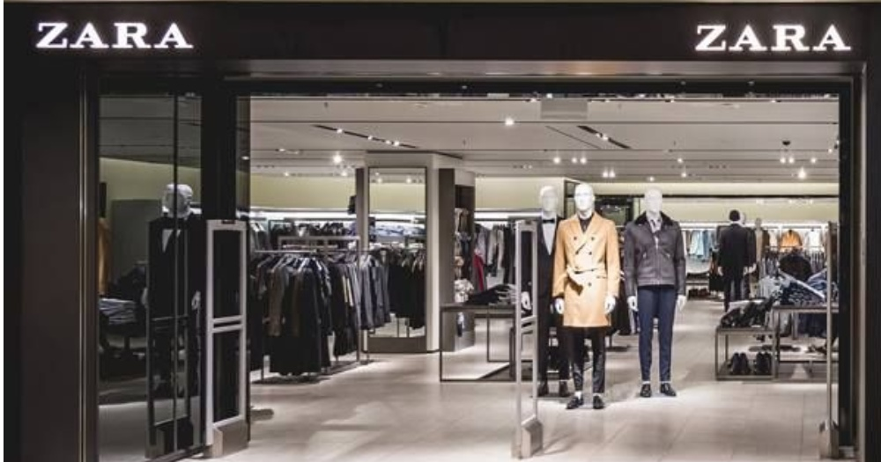

Inditex, the owner of Zara, will close up to 1,200 of its smaller stores worldwide by 2021, [*Reuters*](https://uk.reuters.com/article/uk-inditex-results/zara-owner-inditex-books-first-loss-shifts-to-big-stores-and-online-idUKKBN23H0RP) reported.

Inditex, which owns multiple fashion brands such as Massimo Dutti, Pull & Bear, and Bershka made the announcement following news that it had suffered its first loss due to the Covid-19 outbreak.

The outbreak had resulted in operations to be suspended at most of its stores.

## Smaller stores affected

Inditex will "absorb" between 1,000 and 1,200, most of which are smaller stores. The stores expected to close will be located in Asia and Europe, according to [The Guardian](https://www.theguardian.com/business/2020/jun/10/zara-owner-to-close-up-to-1200-fashion-stores-around-the-world).

However, Inditex assured that the "headcount will remain stable" and that staff will be offered other job roles such as handling online purchases.

The Guardian said that the overall number of stores will fall from 7,412 to between 6,700 and 6,900. This number takes into account the opening of 450 new stores.

Inditex faced a net loss of €409 million (S$644.6 million) from February to April 2020, following a 44 per cent drop in sales to €3.3 billiob (S$5.2 billion).

The losses came from other Inditex brands, besides Zara.

## Refocusing

*Guardian* revealed that the company has a €2.7 billion (S$4.25 billion) plan to upgrade technology at stores in order to push online sales. They hope that online sales will comprise 25 per cent of sales by 2022, as compared to 14 per cent now.

Online sales rose by 95 per cent in April during the Covid-19 outbreak, compared to the previous year.

**H&M vs. Zara vs. Uniqlo: An Overview**

H&M, Zara, and Uniqlo are three international clothing retailers with over 2,000 stores each worldwide. The competitive companies target similar markets but employ different strategies in their business models to manage the distribution of product lines.

These three clothing distributors have differing approaches to their ownership of materials, sourcing of manufacturing, and treatment of auxiliary brands. Here's a look at each company, what their focus is, who their customers are, and how they have developed their brands over the years.

KEY TAKEAWAYS

* H&M, Zara, and Uniqlo are international clothing retailers with more than 2,000 stores each worldwide.
* H&M is the oldest, has the largest number of physical stores, and has expanded from its budget roots to include seven other brands.
* Zara is most prominent in its native Spain but has managed to expand globally, expanding its brand to include Zara Home.
* Uniqlo is particularly geared toward its native market in Japan but has expanded to include 19 markets worldwide.

**H&M**

[H&M](https://www2.hm.com/en_us/index.html), or Hennes & Mauritz, is the oldest of the three. The discount retailer, known for its affordable prices, was founded in Sweden in 1947 and has, over the years, grown into one of the most recognizable brands in the fashion industry.4 H&M is publicly traded, both in its native Sweden and in the United States. It went public in Sweden in 1974.5

H&M has expanded considerably over the last few years. It has 4,372 stores open worldwide, as of April 2021, far more physical stores than Zara and Uniqlo, by far.6 H&M's infiltration into the U.S. market has also been more prolific than that of its competitors, with 559 stores open.7 H&M has stated plans to roll out thousands more in the next few years. At the same time, H&M has had to close select stores as many customers take their purchases online, reflecting the broader transition in the retail world from physical sales to a more [e-commerce](https://www.investopedia.com/terms/e/ecommerce.asp)-based model.8

Despite being known as a budget retailer, H&M also owns COS, which stands for Collection of Style. COS sells higher-end products at higher prices than H&M. H&M also owns six other brands: Monki, Weekday, H&M Home, & Other Stories, Afound, and Arket.9

Part of H&M's strategy to boost sales has been to offer customers featured products that have been marketed as designer collaborations with well-known names such as Versace and Alexander Wang. By offering these products within H&M locations, the company boosts its own reputation by partnering with valuable figures in the fashion world, and it offers its customers additional lines for purchase that are different in look and style from the mainstay designs of the company.

**Zara**

[Zara](https://www.zara.com/us/) is the youngest of the trio, having begun in Spain in 1975. The company is owned by textile giant Inditex and is its flagship brand.10 Zara’s ownership of its supply-chain steps allows for more rapid product turnover; Zara can design a product and have it sold in stores a month later.11

Zara boasts 2,200 stores in 96 countries. It currently has 99 stores open in the United States, with a majority of its locations worldwide in Spain, where there are 464 locations (including Zara Home).1213

Zara's strategy is to offer a higher number of available products than its competitors. While most clothing retailers manufacture and offer to the public for sale 2,000 to 4,000 different articles of clothing, Zara's production has been markedly higher, at over 10,000 pieces produced per year.14 This unique feature of the company's strategy has allowed Zara to appeal to a broader number of customers with unique tastes.

**Uniqlo**

[Uniqlo](https://www.uniqlo.com/us/en/home/) was purchased by Fast Retailing Co. in November 2005 and was originally founded in 1949 in Japan.1516 Its business model is based on that of The Gap.

Uniqlo has opened 2,000 stores in over 25 markets worldwide.1 Uniqlo's introduction into the U.S. market occurred in 2006; currently, there are 47 stores in the U.S. as of March 2021.17

Uniqlo's distribution channels are concentrated in its country of origin; 806 Uniqlo store locations are in Japan.18 Uniqlo's distribution strategy has centered on the timing of its products' introductions into stores, with new products created as a function not of quantity, but of demand.

Uniqlo responds to changing trends in Japanese fashion and specifically caters its designs to mimic the minimalistic style that is popular in Japan. This affects the appeal that Uniqlo may have for western [distribution channels](https://www.investopedia.com/terms/d/distribution-channel.asp), and may be the determining reason behind its low number of store locations in the U.S.19

**Key Differences**

By purchasing and developing brands that have unique styles, H&M hopes to appeal to a wider market of clothing shoppers. Each H&M brand has its own price range and visual concept; for instance, Collection of Style (COS) is sold at a higher [average price](https://www.investopedia.com/terms/a/averageprice.asp) than H&M's principal basket of products and focuses on the European markets. Alternatively, Monki sells clothing pieces that are half the price of those sold by Collection of Style and features designs that are comparably youthful.

Zara divides the products sold within its stores into lower garments and upper garments, with price points being higher for the upper garments. Zara hopes to be perceived as a high-end retailer with affordable prices. Its flagship stores are strategically opened in key traffic points worldwide that have high real estate costs, such as its Fifth Avenue location in New York City. Zara does not stress [advertising](https://www.investopedia.com/terms/m/marketing.asp) as a part of its [branding strategy](https://www.investopedia.com/articles/financial-theory/11/branding-ultimate-economic-moat.asp), differing from Uniqlo; the company instead funnels the dollars that would have gone toward advertising into new store openings.20

The adapted strategy from The Gap that Uniqlo employs is to position its brand as private-label apparel; the company creates its own clothing, and Uniqlo only sells it within the confines of its [brick-and-mortar](https://www.investopedia.com/terms/b/brickandmortar.asp) stores and on its website. The company also uses sporting events to appeal to the general population. The designs that Uniqlo creates tend to be more simplistic and practical than those sold by Zara and H&M, and they appeal to a different audience as a result.

Special Considerations

H&M, like many commercial clothing retailers, outsources the manufacture of its designs to countries such as Cambodia and Bangladesh where labor is cheap. H&M does not directly own any factories and instead partners with 800 suppliers worldwide, most of which are located in Europe and Asia.21

To transport its goods from factories to stores, the retailer relies on rail and sea as a means to promote efficiency within its internal logistics.22 The designers of H&M's products are based out of the company's [home office](https://www.investopedia.com/terms/h/home-office.asp) in Stockholm.23

Zara is able to design, manufacture, and sell its products in stores quickly because the company owns many of the vertical factors of production. Zara's main manufacturing plant is in the city of La Coruña, where the clothing retailer was founded.24 Of all of the products that Zara manufactures, 54% of production facilities are in Spain, Portugal, Turkey, and Morocco.25

Zara's approach to fashion differs from Uniqlo's in that it attempts to predict customer needs rather than follow current fashion trends. The turnover of products within the store is very high, with an average article of clothing remaining on the shelf for only a month.

Uniqlo manufactures its clothing within Japan. It began using [cheap labor](https://www.investopedia.com/terms/c/cost-of-labor.asp) in China when Japan experienced a [recession](https://www.investopedia.com/terms/r/recession.asp) in the 1990s. The company has contracts with 84 fabric mills.27 Uniqlo has also forged a partnership with the Japanese denim manufacturer Kaihara Denim.

The company does so well because it has **a phenomenal operating supply chain** and manages its inventory well, creating great value for customers and shareholders alike. It helps set it apart from other fast-fashion retailers like H&M, Forever 21, and the frighteningly cheap Primark.

**Latest News**

**Straits Times November 2021**

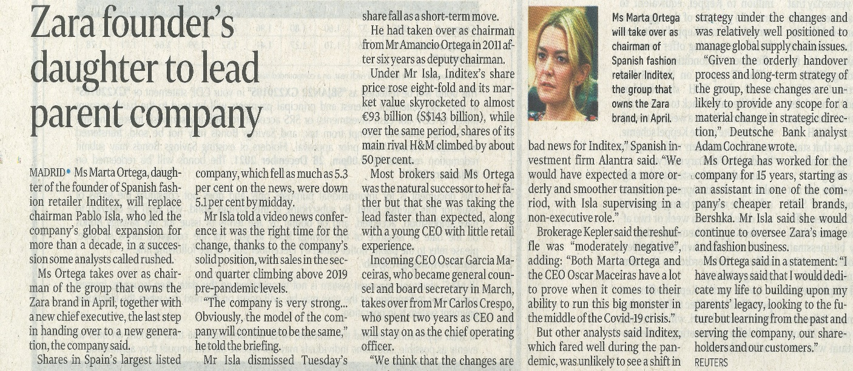

**Organisation Chart**

**In Singapore**

**Janet Ling**

**Head of Retail**

**Digital Office**

**George Ruiz**

**Business Development**

**Manager**

**Alvin Tan**

**Property Director**

**In Spain**

**Mr Sergio Valdez**

**SVP of AP Retail**

**(CTO)**

**Zara Key Contact Points Profile (from LinkedIn)**

***Sergio Valdez | SVP of AP Retail (Located in Spain)***

Sergio Valdez has been with Inditex for the past 8 years. He was previously with PVH Corp. an American clothing company which owns brands such as Tommy Hilfiger, Calvin Klein, Warner's, Olga and True & Co.. The company also licenses brands such as Kenneth Cole New York and Michael Kors.

***Janet Ling | Head of Retail (Located in Singapore)***

Janet Ling has been with Inditex for the past 5 years. She was promoted to Head of Retail 3 years ago. She was the Business Development Manager prior to the promotion. Prior to joining Inditex she worked in Uniqlo as a Business Development Manager.

***George Ruiz | Business Development Manager***

George Ruiz previously from Spain. He has been in Singapore for the past 6 years. He joined Inditex 3 years ago. He was previously from Mango in Business Development.

***Alvin Tan | Property Director***

Alvin Tan has been with Inditex for the past 7 years. He was promoted to Property Director. Prior to joining Inditex he worked in CapitaLand as a facilities manager.